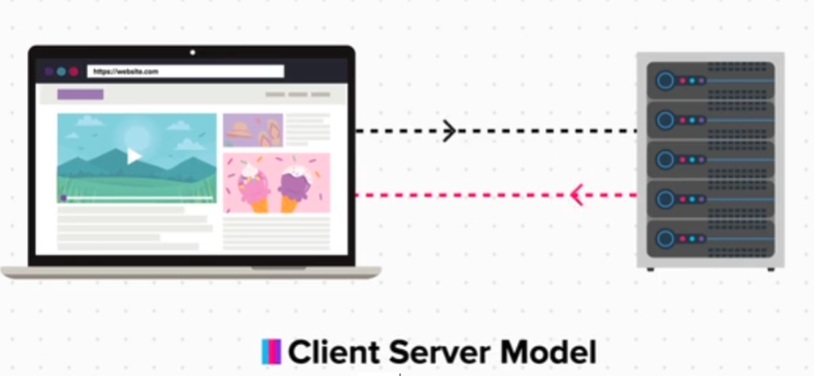

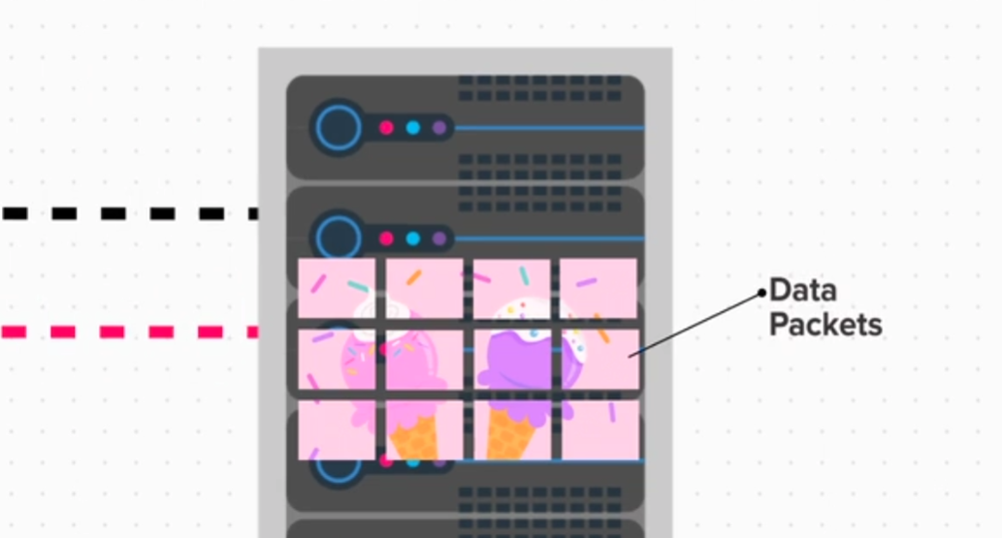

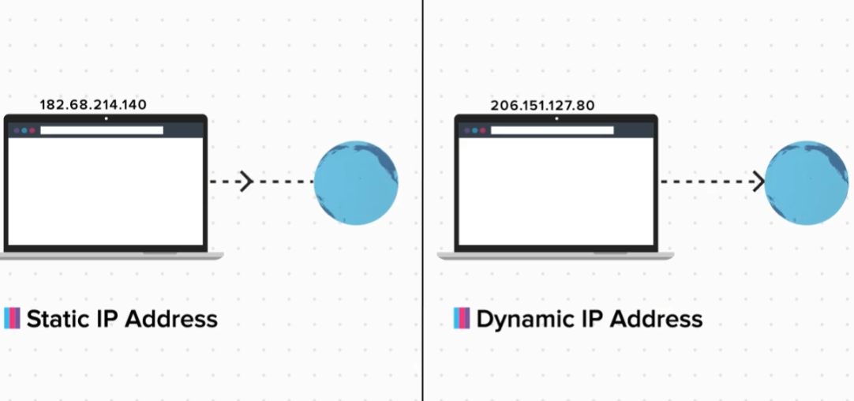

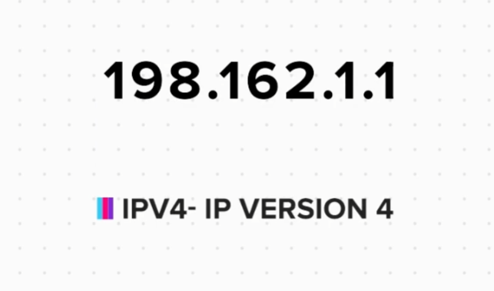

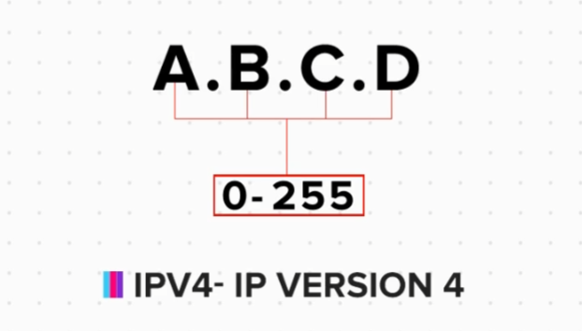

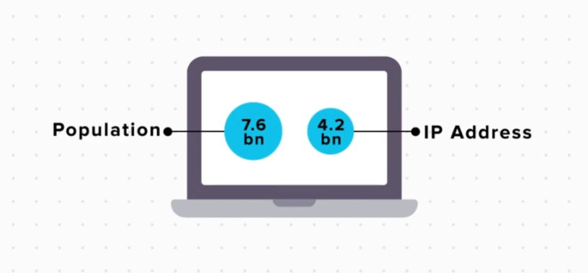

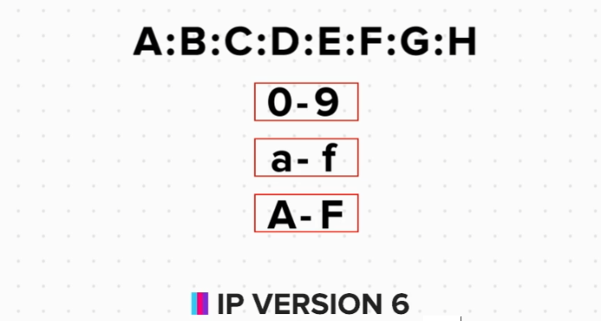

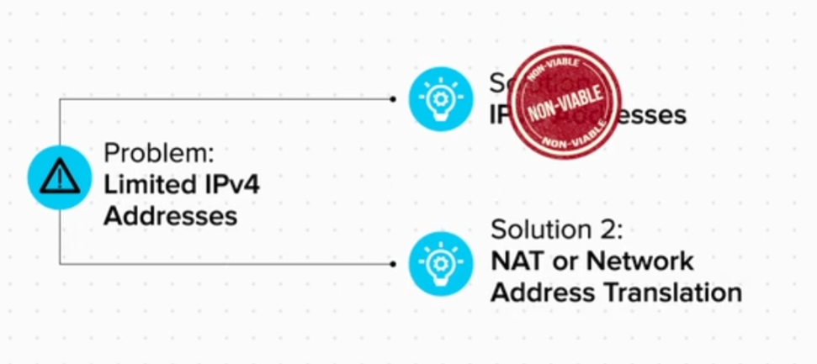

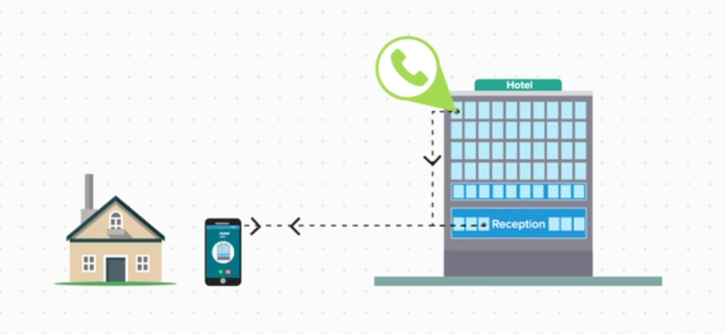

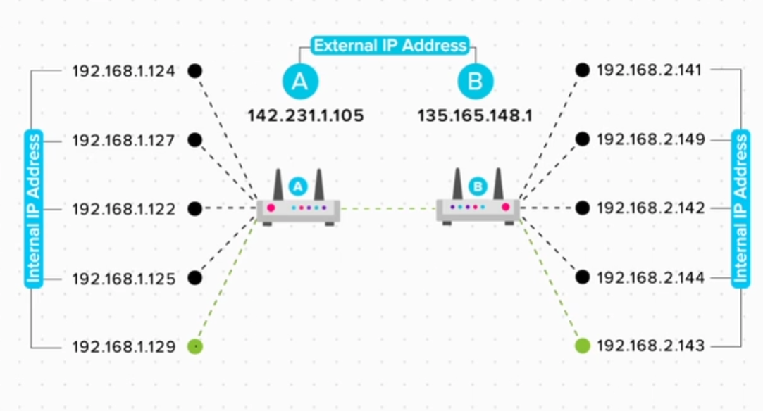

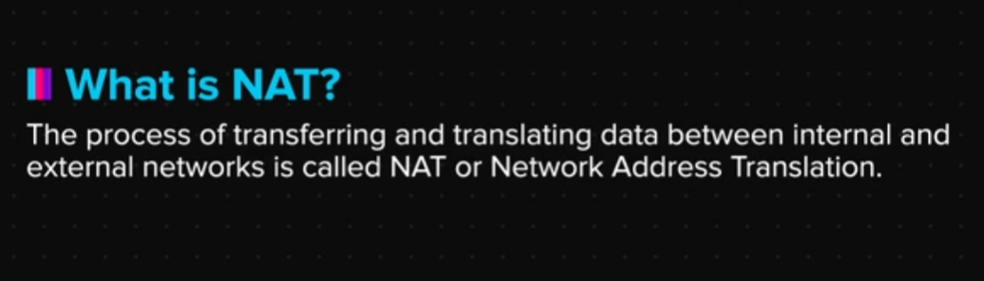

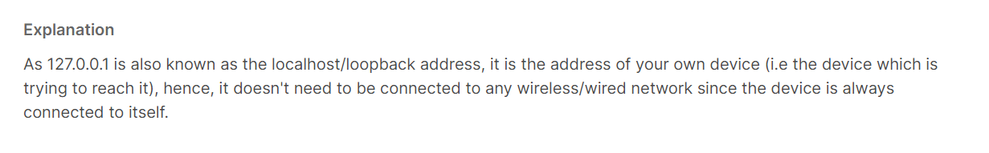

**IP Address Range**

Now that we know about IP address, we must know that some IP address ranges are reserved for special usages. Here is a list:

For small internal networks (Like your home or small office): 192.168.0.0 to 192.168.255.255

For large internal networks (Like large MNCs, colleges, schools): 172.16.0.0 to 172.31.255.255

For massive internal networks (Like telecom networks, satellites): 10.0.0.0 to 10.255.255.255

127.0.0.1 : This is called the LoopBack address and is used as the address of your own machine. (We will look at its uses later)

**Exercise**

1. Check for your internal and external IP addresses using the steps given below.

For Windows Users:

1. Click on the start menu and type cmd to open the command prompt.

2. Type ipconfig and press enter.

3. Your will see your Internal IP Address.

For Linux/Mac Os users:

1. Open your "Terminal" (Ctrl/Cmd + Alt + T).

2. Type ifconfig and press enter.

3. Your will see your Internal IP Address.

To find the external IP address, just search for ip address on google and to use these free websites to check your external IP address.

whatsmyip.com

ipchicken.com

ipcow.com

2. Find the internal and external IP addresses of 2 devices connected to the same WiFi network and check the following:

a. Are the Internal Addresses same?

b. Are the External Addresses same?

c. Does the Internal Address change after restarting the WiFi router?

d. Does the External Address change after Restarting the WiFi router?

Summary

Now that we have come to the end of this topic, you should be able to:

1. Explain the core concepts of IP addressing

2. Understand how your household network and the internet works

3. Extract the various IP addresses of your own devices

4. Classify IP addresses based on version, network infrastructure, and availability

5. Explain the concept of NAT